**Ex. No.: 11b)**

**Date: 09-04-2025**

**LRU**

**Aim:**

To write a c program to implement LRU page replacement algorithm.

**Algorithm:**

1: Start the process

2: Declare the size

3: Get the number of pages to be inserted

4: Get the value

5: Declare counter and stack

6: Select the least recently used page by counter value

7: Stack them according the selection.

8: Display the values

9: Stop the process

**Program Code:**

#include <stdio.h>

int findLRU(int time[], int n) {

int i, min = time[0], pos = 0;

for (i = 1; i < n; ++i) {

if (time[i] < min) {

min = time[i];

pos = i;

}

}

return pos;

}

int main() {

int frames[10], pages[30], counter[10];

int i, j, k, pos, max, faults = 0, time = 0;

int n, f;

printf("Enter number of frames: ");

scanf("%d", &f);

printf("Enter number of pages: ");

scanf("%d", &n);

printf("Enter reference string: ");

for (i = 0; i < n; ++i)

scanf("%d", &pages[i]);

for (i = 0; i < f; ++i) {

frames[i] = -1;

counter[i] = 0;

}

printf("\n");

for (i = 0; i < n; ++i) {

int flag1 = 0, flag2 = 0;

for (j = 0; j < f; ++j) {

if (frames[j] == pages[i]) {

time++;

counter[j] = time; // Update recent use time

flag1 = flag2 = 1;

break;

}

}

if (flag1 == 0) {

for (j = 0; j < f; ++j) {

if (frames[j] == -1) {

time++;

faults++;

frames[j] = pages[i];

counter[j] = time;

flag2 = 1;

break;

}

}

}

if (flag2 == 0) {

pos = findLRU(counter, f);

time++;

faults++;

frames[pos] = pages[i];

counter[pos] = time;

}

// Display current frame state

for (k = 0; k < f; ++k) {

if (frames[k] != -1)

printf("%d ", frames[k]);

else

printf("-1 ");

}

printf("\n");

}

printf("\nTotal Page Faults = %d\n", faults);

return 0;

}

**OUTPUT:**

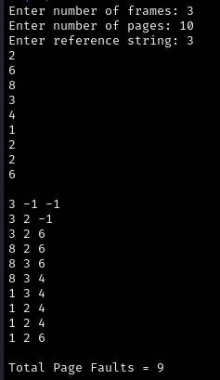

**RESULT:**

Hence, page faults that occur using LRU page replacement technique has been found.